Disclaimer: I DO NOT claim or guarantee whether the answer written here is 100% accurate. If you feel something is not accurate or out-of-order or want to contribute, it will be a great help, if you let me know. Question which are crossed refers to the repeated question which has been answered already but this rule hasn’t been applied to all repeated question. Use Chrome to read this PDF properly. All question are from Pokhara University board exam papers of BCA.
Author: Pranav Bhattarai

Web Technology I

Fall 2021
1 a) Define protocol. Differentiate between TCP and UDP with some example.
1 b) Define lists used in HTML5. Write down the three types of list with example.
2 a) Explain nested table with suitable example. What is cell spacing and cell padding?
2 b) Define hyperlinking. How many ways we can link to document explain with example?
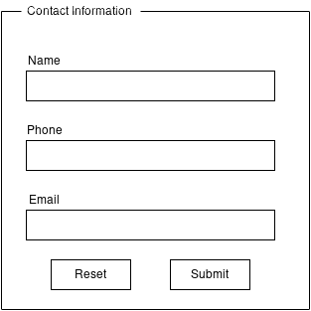
3 a) What is Event Handler? Explain about onclick Event, onsubmit Event, onmouseOver and onmouseout.

3 b) Write the code to create a form given below: ------------------------------->
Write javascript for from validataion. All fields are required.

4 a) Explain with code for linking CSS by inline, external and import methods.
4 b) Differentitate between padding and margin with example. Explain CSS properties.
5 a) Write some basic rules for creating XML document. What is the difference between XML and HTML document?
5 b) Define <div> and <span> tag with attractive CSS. How do you create with popup box in JavaScript?
6 a) Define DOM with hierarchy. Difference with Client side and Server side scripting with example.
6 b) Define responsive design. What are the issues related to cross-browser compatibility explain.
7. Write short notes on any two:
a) jQuery with its advantages
b) Web server and Web Browser
c) DTD

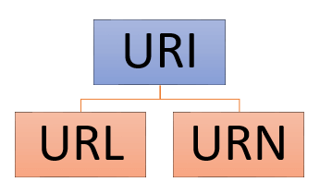
Spring 2019

1 a) What do you mean by URL? Difference between URL and URI with example.

URL | URI
1.URL stands for Uniform Resource Locator. | URI stands for Uniform Resource Identifier.
2. URL is a subset of URI that specifies where a resource is exists and the mechanism for retrieving it. | A URI is a superset of URL that identifies a resource either by URL or URN (Uniform Resource Name) or both.
3. The main aim of URL is to get the location or address of a resource. | The main aim of URI is to find a resource and differentiate it from other resources using either name or location.
4. URL is used to locate only web pages. | URI is used in HTML, XML and other files XSLT (Extensible Stylesheet Language Transformations) and more.
5. The scheme must be a protocol like HTTP, FTP, HTTPS, etc. | In URI, the scheme may be anything like a protocol, specification, name, etc.
6. Protocol information is given in the URL. | There is no protocol information given in URI.
7. It contains components such as protocol, domain, path, hash, query string, etc. | It contains components like scheme, authority, path, query, fragment component, etc.
8. All URLs can be URIs. | Not all URIs are URLs since a URI can be a name instead of a locator.
9. Example of URL is: https://firefox.com | Example of URI is: urn:isbn:0-486-27557-4

1 b) What are different list used in HTLM5? Explain each list with suitable example of each.

2 a) Differentiate between <th> and <td> tag in table? Write HTML code to display following output.
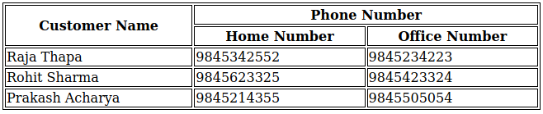
<html>
<style>
table, th, td {
border: 1px solid black;
}
</style>
<body>
<table>
<tr>
<th rowspan="2">Customer Name</th>
<th colspan="2">Phone Number</th>
</tr>
<tr>
<th>Home Number</th>
<th>Office Number</th>
</tr>
<tr>
<td>Raja Thapa</td>
<td>9845342552</td>
<td>9845234223</td>
</tr>
<tr>
<td>Rohit Sharma</td>
<td>9845623325</td>
<td>9845423324</td>
</tr>
<tr>
<td>Prakash Acharya</td>
<td>9845214355</td>
<td>9845505054</td>
</table>
</body>
</html>

Solution:

<th> | <td>
This HTML tags is what we call table header. | This HTML tag is what we call table data.
It is used to write the header of the table. | It is used to write the data inside table row and table column, etc.

The HTML code to display the is written here: ------------------------------------------------------------------>

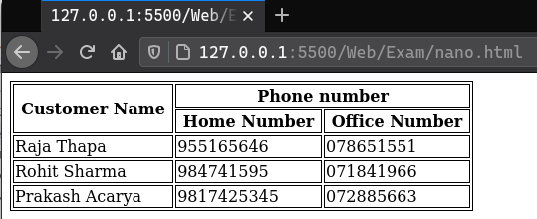
If we run the file in the browser, it will looks like this:
______________________________________________________________________________________________________________________________________________________________

2 b) What is form? What are the form elements used in HTML? Explain with suitable example.
______________________________________________________________________________________________________________________________________________________________

3 a) What is Scripting Language? Differentiate between client side and server side scripting language.

Client Side Scripting Language | Server Side Scripting Language
1. It runs on client machine. | It runs on web server.
2. Security of data depends upon user’s hand. So it can be relatively insecure. | Security of data depends upon developers who are maintaining the hosting the website. So this makes the data a bit secure.
3. Source code is visible to the users. | Source code is not visible to the user because the output of the server side is a HTML page.
4. HTML, CSS and JavaScript are used for client scripting. | Python, PHP, Java, Ruby, etc are use for server scripting.
5. Client-side script is useful to effectively minimize the load to the server. | Server-side scripting is useful in customizing the web pages and implement the dynamic changes in the websites.

______________________________________________________________________________________________________________________________________________________________

3 b) What do you mean by event in JavaScript? Write a HTML code to create login form with two input field Name and Email and JavaScript code that will prevent form submit and display suitable pop up message if either username or password field is empty.

______________________________________________________________________________________________________________________________________________________________

4 a) What is CSS? Write down the advantages of using CSS in web-page. Explain various types of CSS with an example of CSS.

______________________________________________________________________________________________________________________________________________________________

4 b) What do you mean by selectors in CSS? Explain any 5 selectors with an example of each.
CSS selectors are used to "find" (or select) the HTML elements we want to style.
We can divide CSS selectors into five categories: //These are “categories”, not types.

i) Simple selectors (select elements based on name, id, class)
ii) Combinator selectors (select elements based on a specific relationship between them)
iii) Pseudo-class selectors (select elements based on a certain state)
iv) Pseudo-elements selectors (select and style a part of an element)
v) Attribute selectors (select elements based on an attribute or attribute value)

______________________________________________________________________________________________________________________________________________________________

5 a) What do you mean by text formatting? Explain how text formatting and text controlling is done through CSS with appropriate example.

Text formatting is a way to write to text in way which can draw the reader’s attention to specific part of the document and emphasize the important part of the document. This is done by changing color, size and font of the text.

CSS text formatting and text controlling is done in this ways:
i) Text color
ii) Text alignment
iii) Text decoration
iv) Text transformation
v) Line height
vi) Text direction
vii) Text shadow
viii) Word spacing

______________________________________________________________________________________________________________________________________________________________

5 b) Mention basic rules for creating XML document. Write about XSL.

______________________________________________________________________________________________________________________________________________________________

6 a) What is XML schema? Write about XML, SAX and XML document.

______________________________________________________________________________________________________________________________________________________________
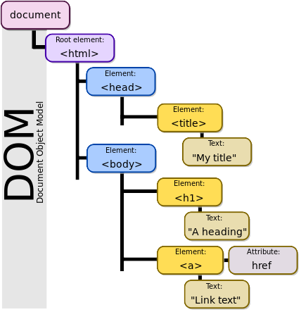
6 b) Explain page layout issue in details.
7. Write shorts notes on any two:

- DOM
The Document Object Model (DOM) is a programming API for HTML and XML documents. It defines the logical structure of documents and the way a document is accessed and manipulated.

The Document Object Model is a programming API for documents. The object model itself closely resembles the structure of the documents it models.

It represents the page so that programs can change the document structure, style, and content. The DOM represents the document as nodes and objects. That way, programming languages can connect to the page.

A Web page is a document. This document can be either displayed in the browser window or as the HTML source. But it is the same document in both cases. The Document Object Model (DOM) represents that same document so it can be manipulated. The DOM is an object-oriented representation of the web page, which can be modified with a scripting language such as JavaScript.

______________________________________________________________________________________________________________________________________________________________

- jQuery
jQuery is a fast, small, and feature-rich JavaScript library. It makes things like HTML document traversal and manipulation, event handling, animation, and Ajax much simpler with an easy-to-use API that works across a multitude of browsers. With a combination of versatility and extensibility, jQuery has changed the way that millions of people write JavaScript.
var divs = $("div"); // Find all divs
var divs = jQuery("div"); // Also find all divs, because
console.log($ === jQuery);//”true”
$ sign is as an alias to represent jQuery. A short version of jQuery →

jQuery was released in 2006 under MIT license. The current stable version is: 3.5.1

______________________________________________________________________________________________________________

- HTTP and HTTPS
______________________________________________________________________________________________________________________________________________________________

Fall 2019

1 a) What is WWW. Explain different protocols used in internet.
The World Wide Web (WWW), commonly known as the Web, is an information system where documents and other web resources are identified by Uniform Resource Locators (URLs), which may be interlinked by hypertext, and are accessible over the Internet. The resources of the WWW can be accessed by users by a software application called a web browser.

The World Wide Web was originally designed in 1991 by Tim Berners-Lee while he was working in CERN.

1 b) What are different types of list in HTML? Write HTML code to generate different list.
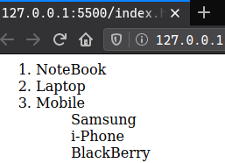
i. Notebook
ii. Laptop
iii. Mobile
Samsung
i-phone
Black Berry
<html>
<ol>
<li>NoteBook</li>
<li>Laptop</li>
<li>Mobile</li>
<ul>Samsung</ul>
<ul>i-Phone</ul>
<ul>BlackBerry</ul>
</ol>
</html>

Ans:
There are three types of list:
- Unordered list －used to group a set of related items in no particular order.
This list is used when a set of items can be placed in any order. An example is a shopping list:
- milk
- bread
- butter
Although the items are all the part of one list, we could put items in any order and the list would still make sense.
In HTML file, it looks like:
<html>
<body>
<li> bread</li>
<li> coffee</li>
<li> milk</li>
</body>
</html>
If we open the file in any browser, it will look like this:
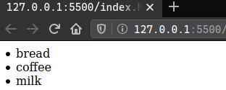

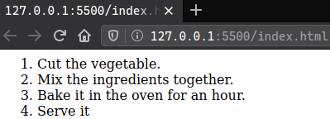
- Ordered list － used to group a set of related items in a specific order.
This list is used to display a list of items that should be in a specific order. An example would be a cooking instructions:
1. Cut the vegetable.
2. Mix the ingredients together.
3. Bake it in the oven for an hour.
4. Serve it.
If the list items were moved around different order, the information would no longer make sense. So in this situation, order is important.
In Http file, an ordered list looks like this.
<html>
<body>
<ol>
<li>Cut the vegetables.</li>
<li>Mix the ingredients together.</li>
<li>Bake it in the oven for an hour.</li>
<li>Serve it.</li>
</ol>
</body>
</html>
If we open the file in any browser, it will look like this:
- Description list － used to display name/value pair items such as items and definition.
A description list is a list of terms, with a description of each term. Three tags are used for description list:
The <dl> tag defines the description list.
The <dt> tag defines the term (name).
The <dd> tag describes the term.
A HTML example to clarify how description list work is given below:
<html>
<body>
<dl>
<dt>Elephant</dt>
<dd>A wild animal.</dd>
<dt>Dog</dt>
<dd>A domestic animal.</dd>
</dl>
</body>
</html>>
If we open the file in any browser, it will look like this:
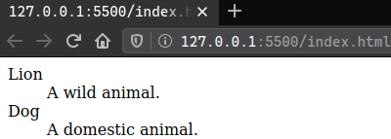

______________________________________________________________________________________________________________________________________________________________

2 a) Explain nested table with suitable example? What is cell spacing and cell padding?
<html>
<body>
<table bordercolor="yellow" border="30">
<tr>
<td>
<table bordercolor="green" border="15">
<tr>
<td>Table inside a table = Nested Table</td>
</tr>
</table>
</td>
</tr>
</table>
</body>
</html>
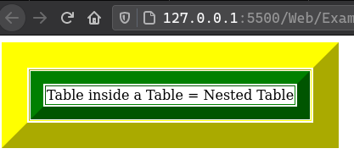
A nested table is an HTML table that has another table inside that table.

Using nested table can increases the page load time because normally when a page loads, the browser starts to render elements from the top of the HTML and loads it sequentially down the page; however, with nested table, it has to find the end table before it can display the entire table.

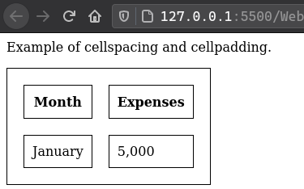
<html>
<style>
table, th, td{
border: 1px solid black;
}
</style>

<body>
<p>Example of cellspacing and cellpadding.</p>
<table cellspacing="20" cellpadding="10">
<tr>
<th>Month</th>
<th>Expenses</th>
</tr>
<tr>
<td>January</td>
<td>5,000</td>
</tr>
</table>
</body>
</html>

Cell-padding and Cell-spacing are the attributes used in table formatting, it actually sets the white spaces in your table cells. These are the significant properties of a web document.

Cell Spacing
It is used specify the distance between the cells.
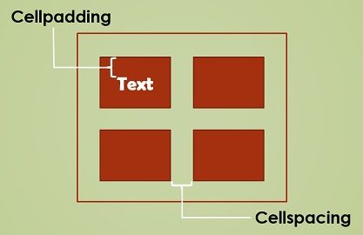
Cell-spacing attribute is no longer supported starting HTML5.
<table cellspacing="value" >
< ……… >
</table>

Cell Padding
It is used specify empty space between the cell edge and its contents.
Cell-padding attribute is no long supported starting HTML5.
<table cellpadding="value" >
< …...…. >
</table>
______________________________________________________________________________________________________________________________________________________________

2 b) What do you mean by form? Write html code to generate following form.
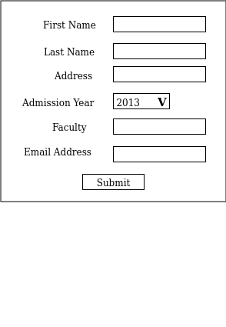

// the drop-down menu with default selection of 2013

3 a) What is JavaScript? Differentiate between client side and server side scripting language.

JavaScript (JS) is a lightweight, interpreted, or just-in-time compiled programming language with first-class functions. While it is most well-known as the scripting language for Web pages, many non-browser environments also use it, such as Node.js, Apache CouchDB and Adobe Acrobat. JavaScript is a prototype-based, multi-paradigm, single-threaded, dynamic language, supporting object-oriented, imperative, and declarative (e.g. functional programming) styles,

3 b) Explain Window and String object in JavaScript. Explain any five String object methods with example.
4 a) Why we use CSS? Explain different types of selector in CSS with example.
4 b) What do you mean by text formatting? Explain how text formatting is done through CSS with appropriate example.
5 a) Explain inline, internal and external way to insert CSS with example.
5 b) List the advantages of XML? What is difference between XML and HTML?
6 a) Define XML schema? Mention the basic rules for creating XML document.
6 b) Describe XML schema? Mention the basic rules for creating XML document.
7 Write short notes on any two:
a) Domain name
b) jQuery
c) CSS background

Spring 2018

1 a) Differentiate between HTTP and HTTPS. What are the issues related to domain name registration? Explain.
HTTP | HTTPS
It stand for hypertext transfer protocol. | It stand for hypertext transfer protocol secure.
It uses port 80 by default. | It uses port 443 by default.
It operates at TCP/IP protocol. | HTTPS does not have any separate protocol. It operates using HTTP but uses encrypted TLS/SSL connection.  TLS = Transport Layer Security  SSL = Secure Socket Socket Layer is now deprecated with the release of TLS 1.0 in 1999
HTTP website doesn’t need SSL certificate. | HTTPS website require SSL certificate.
HTTP website don’t use data encryption. | HTTP website use data encryption.
It loads faster than HTTPS. | It loads slower than HTTP.
The URL begins with http:// | Its URL begin with https://

Issues related to domain name registration are:
i) You should pick a domain name that is not the trademark of another company, particularly a well-known trademark. This is because most laws treat registration of another person's trademark as a domain name as trademark infringement, also known as 'cybersquatting', and your SME (Subject matter Expert) might have to transfer or cancel the domain name, and also pay damages.

ii) It is wise to avoid domain names that include certain other controversial words such as geographical terms (e.g. Champagne, Beaujolais), names of famous people, generic drug names, names of international organizations, and trade names (e.g. name of another person's business), that might interfere with the rights of others or international systems of protection.

============================================================================================

1 b) What is hyperlink? What are the different types of links used in HTML?
Hyperlink is an element in an HTML document that links to either another portion of the document or to another document altogether.
On web-pages, hyperlinks are usually colored purple or blue and are sometimes underlined. A hyperlink can be thought of as an interface that links a source to a target. Clicking the hyperlink at the source will navigate to the target.

The different types of links used in HTML are:

Anchor:
An anchor hyperlink is a link bound to a portion of a document— generally text, though not necessarily. For instance, it may also be a hot area in an image (image map in HTML), a designated, often irregular part of an image. One way to define it is by a list of coordinates that indicate its boundaries. For example, a political map of Africa may have each country hyperlinked to further information about that country. A separate invisible hot area interface allows for swapping skins or labels within the linked hot areas without repetitive

2 a) Explain ordered list in HTML with an example. Write a HTML code to create the following table:
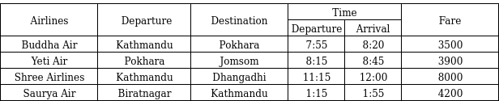
<html>
<style>
table, th, td {
border: 1px solid black;
border-collapse: collapse;
}
</style>
<body>
<table style="width:100%">
<tr>
<th rowspan="2"> Airlines</th>
<th rowspan="2"> Departure</th>
<th rowspan="2"> Destination</th>
<th colspan="2"> Time</th>
<th rowspan="2"> Fare</th>
</tr>
<tr>
<th>Departure</th>
<th>Arrival</th>
</tr>
<tr>
<td>Buddha Air</td>
<td>Kathmandu</td>
<td>Pokhara</td>
<td>7:55</td>
<td>8:20</td>
<td>3500</td>
</tr>
<tr>
<td>Yeti Airlines</td>
<td>Pokhara</td>
<td>Jomsom</td>
<td>8:15</td>
<td>8:45</td>
<td>3900</td>
</tr>
<tr>
<td>Shree Airlines</td>
<td>Kathmandu</td>
<td>Dhangadhi</td>
<td>1:15</td>
<td>1:55</td>
<td>4200</td>
</tr>
<tr>
<td>Saurya Air</td>
<td>Birtnagar</td>
<td>Kathmandu</td>
<td>1:15</td>
<td>1:55</td>
<td>4200</td>
</tr>
</table>
</body>
</html>

Ans:
HTML code to create above table is written at the side:

And if we run that file in any web browsers, it will look like this:
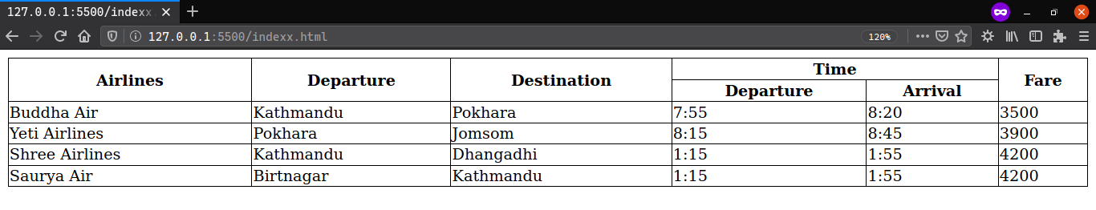

____________________________________________________________________________________________________________________________________________________________

2 b) Explain XML DOM and SAX.

The XML DOM defines a standard way for accessing and manipulating XML documents. It presents an XML document as a tree-structure. The XML DOM also provides an API that allows a developer to add, edit, move, or remove nodes in the tree at any point in order to create an application. All XML elements can be accessed through the XML DOM.
In short, XML DOM is:
- A standard object model for XML
<?xml version="1.0" encoding="UTF-8"?>
<bookstore>
<book category="children">
<title lang="en">HarryPotter</title>
<author>J K. Rowling</author>
<year>2005</year>
<price>29.99</price>
</book>
</bookstore>
</xml>
- A standard programming interface for XML
- Platform- and language-independent
- A W3C standard (W3C stand for Word Wide Web Consortium which is a international community that develops open standards to ensure the long-term growth of the Web.)

In other words: The XML DOM is a standard for how to get, change, add, or delete XML elements. Example of XML DOM given here ------------------------------------------------------------------------------------------>

SAX (Simple API for XML) is an application program interface (API) that allows a programmer to interpret a Web file that uses the XML. SAX is an alternative to using the Document Object Model (DOM) to interpret the XML file. As its name suggests, it's a simpler interface than DOM and is appropriate where many or very large files are to be processed, but it contains fewer capabilities for manipulating the data content.

SAX is an event-driven interface. The programmer specifies an event that may happen and, if it does, SAX gets control and handles the situation. SAX works directly with an XML parser.

SAX was developed collaboratively by members of the XML-DEV mailing list (currently hosted by OASIS). The original version of SAX, which was specific to Java, was the first API for XML in Java to gain broad industry support.

_______________________________________________________________________________________________________________________________________________________
<html>
<body>
<form>
Name <input type="text"><br><br>
Last Name <input type="text"><br><br>
Address <input type="text"><br><br>
Admission Year:
<select name="year">
<option selected> 2013 </option>
<option> 2014 </option>
<option> 2015 </option>
<option> 2016 </option>
<option> 2017 </option>
<option> 2018 </option>
</select><br><br>
Faculty <input type="text"><br><br>
Email Address <input type="text"><br><br>
<input type="submit" value="Submit">
</form>
</body>
</html>
3 a) Write a html code to create the following form.
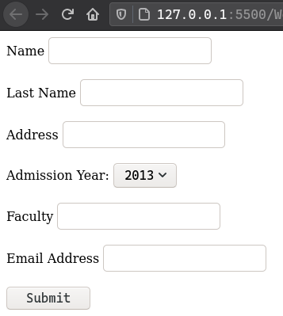
_____________________________________________________________________________________________________________________________________________________________
// A drop-down selection starting from 2013 to 2018

3 b) What is form? What are the form elements used in HTML? Explain with a suitable example.
The HTML form element defines a form that is used to collect user input:
<form>
form element
</form>

Form elements used in HTML are:
i)<input> : It is the most important form element. It is used to display items depending upon the type attribute.
<input name =”Pranav” type =”text”>

ii) <select> : It defines a drop-down list.
<select name=”cars”>
<option value=”car1”>Bugatti</option>
<option value=”car2”>Lamgorghini</option>
<option value=”car3”>Ferrari</option>
</select>

iii) <textarea> : It defines a multi-line input field (a text area).
<textarea name=”message” rows=”10” cols=”30”>
The cat was playing in the garden
</textarea>

iv) <button> : It defines a clickable button.
<button type="button" onclick="alert('Hello World!')">Click Me!</button>

4 a) What is CSS? Write down the advantages of using CSS in web pages. Explain various types of CSS with an example of each.
Cascading Style Sheet (CSS) is used to set the style in web pages which contain HTML elements. It sets the background color, font-size, font-family, color, … etc property of elements in a web pages. It is a language that describes the style of an HTML document. It describes how HTML elements should be displayed.

Advantages of using CSS in web pages are:
- It save lot of time
CSS gives lots of flexibility to set the style properties of an element. You can write CSS once; and then the same code can be applied to the groups of HTML elements, and can also be reused in multiple HTML pages.

- Easy maintenance
CSS provides an easy means to update the formatting of the documents, and to maintain the consistency across multiple documents. Because the content of the entire set of web pages can be easily controlled using one or more style sheets.

- Pages Load Faster
CSS enables multiple pages to share the formatting information, which reduces complexity and repetition in the structural contents of the documents. It significantly reduces the file transfer size, which results in a faster page loading.

- Superior Styles to HTML
CSS has much wider presentation capabilities than HTML and provide much better control over the layout of your web pages. So you can give far better look to your web pages in comparison to the HTML presentational elements and attributes.

- Multiple Device Compatibility
CSS also allows web pages to be optimized for more than one type of device or media. Using CSS the same HTML document can be presented in different viewing styles for different rendering devices such as desktop, cell phones, etc.

There are three types of CSS which are given below:
<html>
<body>
<p style="color: blue ; font-size: 20">Pragraph is now styled using Inline CSS.</p>
</body>
</html>

i) Inline CSS

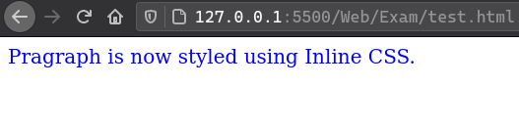
CSS that contains the CSS property in the body section attached with element is known as inline CSS. This kind of style is specified within an HTML tag using style attribute.

ii) Internal or Embedded CSS
<html>
<style>
.example{
color: green;
font-style: italic;
}
</style>
<body>
<div class="example">Internal/Embedded CSS example</div>
</body>
</html>

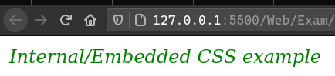
Place CSS rules into an HTML document using the <style> element, which is called embedded CSS.

This tag is placed inside <head>...</head> tags. Rules defined using this syntax will be applied to all the elements available in the document.

iii) External CSS
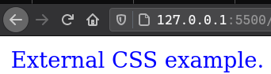
External CSS contains separate CSS file which contains only style property with the help of tag attributes (For example class, id, heading, … etc). CSS property written in a separate file with .css extension and should be linked to the HTML document using link tag. This means that for each element, style can be set only once and that will be applied across web pages.
<html>
<head>
<link rel="stylesheet" href="anotherFile.css"
</head>
<body>
<div class="ClassName">External CSS example.</div>
</body>
</html>
.ClassName {
color: blue;
}

In this program, we need two seperate file in a same directory.
One to keep HTML file and another to keep CSS file.
_________________________________________________________________________________________________________________________________________________________

4 b) Explain structure of XML. Write a basic program to demonstrate the basic XML schema.

XML structure start with Parent root from top of the side. Every XML documents have only one root element. XML documents have a hierarchical structure and is refereed as XML tree. XML documents must contain a root element (one that is the parent of all other elements). All elements in an XML document can contain sub elements, text and attributes. Following are simple XML structures.
<root>
<element>
<subelement> … </subelement>
</element>
</root>

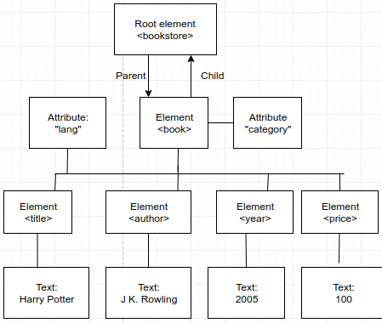

XML have ability to specify new tags and also create a nested tags to make a strict valid tree structure for exchanging data.

A single demonstration of XML document is given below along with the XML code:
<?xml version="1.0" encoding="UTF-8"?>
<bookstore>
<book category="Young Adult">
<title lang="en">Midnight Sun</title>
<author>Stephenie Meyer</author>
<year>2020</year>
<price>$20</price>
</book>
</bookstore>
</xml>

5 a) Explain String and Window object in JavaScript. Write any four built-in methods of Strings object example.
5 b) Write a JavaScript code to validate with following condition:
i) Name field should contain only alphabets.
ii) Email field should contain @ and .(dot)
iii) Password should be at least 8 character long.

6 a) What do you mean by text formatting? Explain how text formatting and text controlling is done through CSS with appropriate example.
6 b) Explain the Page Layout considerations for web pages.
7) Write short notes on any two:
a) Query
b) Scripting Language
c) Client Server Architecture

Fall 2018

1 a) Explain domain name and its hierarchy. Also explain why domain name need to be unique.
Domain name is a part of a network address that identifies its as belonging to a particular website.
Its hierarchy is given below:
Root
|
Top-Level Domains (.com, .org, .net, .edu, etc)
|
Domains(Google, Yahoo)
|
Sub-domains (e.g: www, ww2, ftp)

Domain name need to be unique because it has to be registered before making it publicly available and gains some copywrite right privilege so that other people don’t register the same domain name for their business website.

1 b) Which element is used for links and navigation in HTML? Explain absolute and relative linking with an example.
The <a> (i.e anchor) tag is used for links and <nag> tag is used to define a block of navigation link.

An absolute links contains more information than a relative links. Relative URL are more convenient because they are shorter and often more portable. However, you can use them only to reference links on the same server as the page that contains them.

An absolute URL typically takes the following form:
protocol://domain path

2 a) Discuss the importance of client side & server side scripting language. Why frames are important explain with an example of Frame.
Importance of server side scripting language are:
i) It helps to decrease loading time of the web pages.
ii) It helps to run dynamic pages on browser that do not fully support Javascript.
iii) It increases security and user privacy and is preferred choice for e-commerce, membership and social media sites.

Importance of client side scripting language are:
i) It allows for the creation of faster and more responsive web applications.
iii) Fewer resources are used and needed on web-server. So less load on web-server.
iii) The user’s actions will result in immediate response because they don’t require a trip to the server.

Frame are important because it allows the developer to design a webpage that display multiple webpages within a single web page. To create a frame we need two HTML tags I.e. Frame is not written inside body tag. If we write it inside body, it won’t display.

Below example is very simple demonstration of frame which displays a page is divided in two frames.
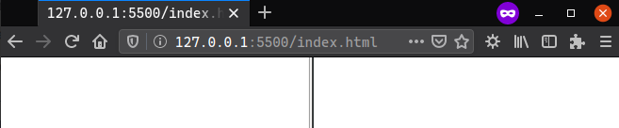
<html>
<frameset cols="50%,50%">
<frame></frame>
<frame></frame>
</frameset>
</html>

We can also insert image, two page or more webpage to display in each frame inside <frame> tag. And the number of frames that can be inside a webpage is not limited. We can put as much frames we need, but there should be enough space for user to view in his screen. So, its pointless too many frames in a single webpage.

Notes that, the frame is no longer supported after HTML5. So website which still uses frames might not be supported in browsers. So basically, frame is not recommended anymore.

2 b) What is domain name? List out the domain name extensions. Also explain domain name hierarchy.

The list of some top domain name extensions are:
i) .com – Commercial
ii) .net – Network
iii) .org – Organization
iv) .int – International Organizations
v) .gov – Owned by government
vi) .edu – Higher Education
vii) .info – Information

Domain name hierarchy goes like this:
Root
|
Top-Level Domains (.com, .org, .net, .edu, etc)
|
Domains(Google, Yahoo)
|
Sub-domains (e.g: www, ww2, ftp)

Top-level domain, also referred to as TLD, is the suffix or extension attached to Internet domain names. There are a limited number of predefined TLDs, such as .com, .net and .org.

Second-level domain (SLD) is the portion of a Uniform Resource Locator (URL) that identifies the specific and unique administrative owner associated with an Internet Protocol address (IP address). The second-level domain name includes the top-level domain name. For example, "microsoft.com" is a second-level domain, as it includes the domain name "Microsoft" and the top-level domain "com."

Third-level domain is used to distinguish second-level domain name. Such as “owa.intermediate.net”. Typically a third-level domain name is used to refer to different servers within different departments of a company. In this case, "owa” points to Outlook Web Access for Exchange customers of intermedia.net. Another example, is www.mydomain.com, "www" is the third-level domain. The default or the most commonly used third-level domain is "www".
Third-level domain names are not mandatory unless the user has a specific requirement. It is actually possible to own a fully functional domain name like "mydomain.com". All that is needed is two levels: the top level domain and the second-level domain name. However, the usage of third-level domain names can really add clarity to domain names, which makes them more intuitive.

3 a) Define function with its type in Java Script. Write down the Java Script code to validate email and mobile number from the user input form.
A function is a JavaScript is a set of statements that performs a task or calculates a value. A JavaScript function is executed when something calls it.
Basic syntax:
function validFunctionName(parameter) {
return statement;
}

There are 3 type of functions in java Script are:
- Named function
- Anonymous function
- Immediately invoked function expression which run as soon as the browser finds it.

Email validation is hard. With the vast amount of complex, but valid email addresses that exist today, the only way to truly tell if an email address is valid is to send the email and see if it bounces. In the given script, there are two file. One is html file for webpage out look and another JavaScript file which is check whether the mail and number is in correct format.

This is abc.html file.

<html>
<body onload='document.form1.text1.focus()'>
<div class="mail">
<h1>Enter a email and phone number </h1>
<form name="form1" action="/abc.html">
<ul>
<li>Email<input type='text' name='mail'/></li><br>
<li>Phone<input type='text' name='phone'/></li>
<li>&nbsp;</li>
<li class="submit"><input type="submit" name="submit" value="Submit" onclick="ValidateData(document.form1.mail, document.form1.phone)"/></li>
<li>&nbsp;</li>
</ul>
</form>
</div>
<script src="EmailValidation.js"></script>
</body>
</html>

This is EmailValidation.js file.
function ValidateData(email, phone) {
if(ValidateEmail(email))
ValidatePhone(phone);
}
function ValidateEmail(inputText) {
var mailformat = /^\w+([\.-]?\w+)*@\w+([\.-]?\w+)*(\.\w{2,3})+$/;
if(inputText.value.match(mailformat)) {
alert("Email verified");
return true;
}
else {
alert("You have entered an invalid email address!");
return false;
}
}
function ValidatePhone(inputtxt) {
var phoneno = /^\d{10}$/;
if(inputtxt.value.match(phoneno)) {
alert("Phone number verified.");
return true;
}
else {
alert("Invalid phone number.");
return false;
}
}

3 b) The following conditions are given for PU entrance Test:
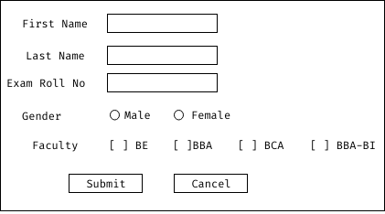

Design above form using HTML and CSS and use java script to prevent from wrong entry by the user.
Ans:
<html>
<body>
<form action="/ActionPage.html">
First Name:<input type="text" name="fname"><br>
Last Name:<input type="text" name="lname"><br>
Exam Roll no:<input type="text" name="roll"><br>
Gender:<input type="radio" name="gender" value="Male">Male
<input type="radio" name="gender" value="Female">Female<br>
Faculty: <input type="radio" name="faculty" value="BE">BE
<input type="radio" name="faculty" value="BBA">BBA
<input type="radio" name="faculty" value="BCA">BCA
<input type="radio" name="faculty" value="BBA-BI">BBA-BI <br>
<input type="submit" value="Submit">&nbsp;&nbsp;&nbsp;<input type="button" value="Cancel">
</form>
</body>
</html>

4 a) Explain events and objects of javascript.
Javascript Events
JavaScript's interaction with HTML is handled through events that occur when the user or the browser manipulates a page. When the page loads, it is called an event. When the user clicks a button, that click too is an event. Other examples include events like pressing any key, closing a window, resizing a window, etc. Developers can use these events to execute JavaScript coded responses, which cause buttons to close windows, messages to be displayed to users, data to be validated, and virtually any other type of response imaginable. Events are a part of the Document Object Model (DOM) Level 3 and every HTML element contains a set of events which can trigger JavaScript Code.
Some types of javascript events are:
- Onclick Event
- Onsubmit Event
- Onmouseover Event
- Onmouseout Event

Javascript Objects
JavaScript is an Object Oriented Programming (OOP) language. JavaScript has several built-in or native objects. In JavaScript, almost "everything" is an object. If you understand objects, you understand JavaScript. These objects are accessible anywhere in the program and will work the same way in any browser running in any operating system.
Here is the list of all important JavaScript Native Objects −
- JavaScript Number Object
- JavaScript Boolean Object
- JavaScript String Object
- JavaScript Array Object
- JavaScript Date Object
- JavaScript Math Object
- JavaScript RegExp Object (RegExp stand for Regular Expression)

4 b) Why style sheet is necessary for web page design? Explain basic syntax and comment. Also explain different types of style sheet according to placement of code.
Style sheet is necessary for web page design because of its speed, maintainability, accessibility, customization, consistency and portability.

5 a) What is the different types of selector in CSS? Explain with example.

5 b) What is difference between SPAN and DIV? Support your answer with example code to justify the difference.

6 a) What do you mean by valid XML document? Explain.

6 b) Why jquery is needed in modern day web page designing? Write the jquery is needed for the text box of form.

7 Write short notes on any two:
a) Page Layout of a webpage:

b) DOM:

c) Search Engine: A search engine a program that searches for and identifies items in a database that correspond to keywords or characters specified by the user, used especially for finding particular sites on the World Wide Web. Search engine is a service that allows Internet users to search for content via the World Wide Web (WWW). A user enters keywords or key phrases into a search engine and receives a list of Web content results in the form of websites, images, videos or other online data. The list of content returned via a search engine to a user is known as a search engine results page (SERP).

2017 Fall
1 a) What do you mean by URL? Differentiate between URL and URI with example.
1 b) What is HTML? Explain HTML document structure? Which element is used for linking and navigation in HTML?
2 a) What are the different types of list in HTML? Write HTML code to create following list.
i. Orange
ii. Mango
iii. Apple
. Red Apple
. Green Apple
iv. Banana

2 b) What do mean by forms? Mention different attribute of form. Write an html code to create following form:
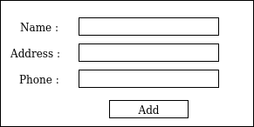

3 a) What is Scripting Language? Differentiate between client side and server side scripting language.
3 b) What do you mean by event in Java Script? Write a HTML code to create login form with two input field Name and Email and Javascript code that will prevent form submit and display suitable pop up message if either username or password field is empty.
4 a) Why style sheet is important in web page design? Explain different types of selectors in style sheet.
4 b) Explain with code for linking CSS by inline, internal, external and import methods.
5 a) What is XML schema? Write about XML SAX and XML document.
5 b) Mention basic rules for creating XML document. Write about XSL.
6 a) Explain why jquery is essential for development web page?
6 b) Explain page layout issue in detail.
7 Write shorts notes on any two:

a) Cross Browser Communication

There are two method through which we communicate between two browsers or any other application is by:
i) Using WebRTC
ii) Using HTTP Relay

WebRTC allows real-time, peer-to-peer, media exchange between two devices. A connection is established through a discovery and negotiation process called signaling.

HTTP Relay provides communication service between HTTP clients. If we are looking for a solution similar to WebRTC but simple to use and supported by all web browsers and HTTP clients, than this is what have to use. In this method, peers exchange data by requesting the same URL.

https://<url>/<method>/<channel>
________________________________________________________________________________________________________________________________________________________

b) HTML Headers
The <header> element represents a container for introductory content or a set of navigational links.

A <header> element typically contains:
→ one or more heading elements (<h1> - <h6>)
→ logo or icon
→ authorship information

The <header> tag support both global and event attributes of HTML.
___________________________________________________________________________________________________________________________________________________________
c) DOM

Spring 2017
1 a) Define protocol. Differentiate between TCP and UDP with some example.

TCP | UDP
1. It stands for Transmission Control Protocol. Also called Internet Protocol. | It stands for User Datagram Protocol.
2. It is a connection-oriented protocol. | It is a connection-less protocol.
3. The speed of TCP is slower. | The speed of UDP is faster.
4. TCP use handshake protocol like SYN, SYN-ACK, ACK, etc. | UDP don’t use handshake protocol.
5. TCP does error checking and also make error recovery. | UDP does error checking but discard erroneous packets.
6. TCP has acknowledgment segments. | It doesn’t have acknowledgment segments.
7. TCP is heavy weight. | UDP is light weight.
8. Header size is 20 bytes. | Header size is 8 bytes.
9. TCP is reliable as it guarantees delivery of data to the destination router. | The delivery of data to the destination can't be guaranteed in UDP.
10. Some real life example/application are those where packet lost is not acceptable like:  → World Wide Web (HTTP)  → SSH, FTP, Telnet  → SMTP, Sending mail  → IMAP/POP, Receiving mail | Some real life example/application are those where some packet lost doesn’t make any difference:  → Tunneling/VPN (lost packets are OK because tunneled protocol takes care of it.  → Media Streaming (loss of some frames are OK)  → Online multiplayer games  → Voice over IP (VoIP)

1 b) Define lists used in HTML5. Write down the three types of list with example.
2 a) Define responsive design. What are the issue related to cross-browser compatibility? Explain.
2 b) Define hyperlinking. How many ways we can link to document? Explain with example.
3 a) Define Style sheet. What are the importance role of using CSS in website? Explain the different types of CSS with example.
3 b) Define table with its important tags. Write down the code to generate the following table:

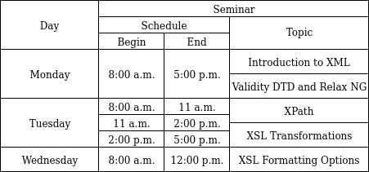

4 a) Define from the GET and POST method. Write down the code to design the following login screen:
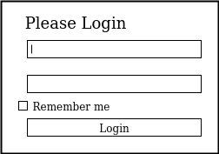

4 b) Define DOM with hierarchy. Difference with Client side and server side scripting with example.
5 a) Define Function with its type in JavaScript. Write down the Javascript code to validate email and mobile number from the user input form.
5 b) Differentiate between Padding and Margin with example. Explain CSS properties.

6 a) Define XML with Naming Rules. Explain DTD and Validation.

DTD
DTD stands for Document Type Definition.
A DTD defines the structure and the legal elements and attributes of an XML document.

6 b) Define <div> and <span> tag with attractive CSS. How do you create with popup box in Javascript?
7 Write down notes on any two:
a) JQuery with its advantages
b) Web server and Web Browser
c) JavaScript Objects

_____________________________________________________________________________________________________________________________________________________________

2015 Spring

1 a) What is protocol? Explain different types of protocols used in internet in detail.

Protocol is the specification of set of rules for a particular type of communication. It is a convention or standard that control or enables the connection, communication and data transfer between computing endpoints. In its simplest form, a protocol can be defined as the rules governing the syntax, semantics and synchronization of communication. Protocol can be implemented by hardware, software or a combination of two.

Different types of protocols used in internet with details are:

i) HTTP: HTTP is a short abbreviation of Hypertext Transfer Protocol. HTTP offers set of rules and standards which govern how any information can be transmitted on the World Wide Web. HTTP provides standard rules for web browsers & servers to communicate.
HTTP is an application layer network protocol which is built on top of TCP. HTTP uses Hypertext structured text which establishes the logical link between nodes containing text. It is also known as "stateless protocol" as each command is executed separately, without using reference of previous run command.

ii) HTTPS: HTTPS is a short abbreviation of Hyper Text Transfer Protocol Secure. It is highly advanced and secure version of HTTP. It uses the port no. 443 for Data Communication. It allows the secure transactions by encrypting the entire communication with SSL. It is a combination of SSL/TLS protocol and HTTP. It provides encrypted and secure identification of a network server.
HTTP also allows you to create a secure encrypted connection between the server and the browser. It offers the bi-directional security of Data. This helps you to protect potentially sensitive information from being stolen.
In HTTPS protocol SSL transactions are negotiated with the help of key-based encryption algorithm. This key is generally either 40 or 128 bits in strength.

iii) FTP: is the protocol used to transmit files between computers connected to each other by TCP/IP network, such as internet. It stands for File Transfer protocol.

iv) TCP/IP: It is stream protocol. This means that a connection is negotiated between a client and a server. Any data transmitted between these two endpoints is guaranteed to arrive thus it is also called lossless protocol. Since the TCP protocol can only connect two endpoints, it is also called a peer-to-peer protocol. It stands for transmission control protocol.

v) UDP: UDP(User Datagram Protocol) is an alternative communications protocol to Transmission Control Protocol (TCP) used primarily for establishing low-latency and loss-tolerating connections between applications on the internet.
UDP run on top of the Internet Protocol (IP) and are sometimes referred to as UDP/IP. UDP enables process-to-process communication. UDP sends messages, called datagrams,and is considered a best-effort mode of communication. UDP is considered a connection-less protocol because it doesn’t require a virtual circuit to be established before any data transfer occurs.
It provides port numbers to help distinguish different user requests and, optionally, a checksum capability to verify that the data arrived intact.

There are many protocol these days to fulfill advance demands.

___________________________________________________________________________________________________________________________________________________________

1 b) How do you add local and remote link in HTML document. Write HTML code to create following list:
1) First item
2) Second item
3) Third list
a) Sub-list item 1
b) Sub-list item 2
c) Sub-list item 3
2 a) Explain client side image map and server side image map with an example.

2 b) What is use of <noframe> tag? Write HTML code using frame to display following output
<<<<<<<<<<< Image here >>>>>>>>>

3 a) What is Event handler? Explain about on Load() and on Click() events.
3 b) What is form validation? What is difference between server side and client side from validation?
4 a) What is the purpose of using JavaScript in HTML document?
4 b) What do you mean by valid XML document? Explain.
5 a) Why style sheet is necessary web page design? Explain basic syntax and way to add comments in style
sheets.
__________________________________________________________________________________________________________________________________________________________

5 b) Explain about different types of selection in CSS.

A CSS selector is the part of a CSS rule set that actually selects the content you want to style. Different types of CSS selection are:

i) Universal Selector: The universal selector works like a wild card character, selecting all elements on a page. Every HTML page is built on content placed within HTML tags. Each set of tags represents an element on the page. Look at the following CSS example, which uses the universal selector:

* {
color: green;
font-size: 20px;
line-height: 25px;
}

ii) Element Type Selector: Also referred to simply as a “type selector,” this selector must match one or more HTML elements of the same name. Thus, a selector of nav would match all HTML nav elements, and a selector of <ul> would match all HTML unordered lists, or <ul> elements. The following example uses an element type selector to match all <ul> elements:

ul {
list-style: none;
border: solid 1px #ccc;
}

iii) ID Selector: An ID selector is declared using a hash, or pound symbol (#) preceding a string of characters. The string of characters is defined by the developer. This selector matches any HTML element that has an ID attribute with the same value as that of the selector, but minus the hash symbol. Here’s an example:
#container {
width: 960px;
margin: 0 auto;
}

iv) Class Selector: The class selector is the most useful of all CSS selectors. It’s declared with a dot preceding a string of one or more characters. Just as is the case with an ID selector, this string of characters is defined by the developer. The class selector also matches all elements on the page that have their class attribute set to the same value as the class, minus the dot. Take the following rule set:

.box {
padding: 20px;
margin: 10px;
width: 240px;
}

v) Descendant Combinator/Selector: The descendant selector or, more accurately, the descendant combinator lets you combine two or more selectors so you can be more specific in your selection method. For example:

#container .box {
float: left;
padding-bottom: 15px;
}

vi) Child Combinator: A selector that uses the child combinator is similar to a selector that uses a descendant combinator, except it only targets immediate child elements:

#container > .box {
float: left;
padding-bottom: 15px;
}

vii) General Sibling Combinator: A selector that uses a general sibling combinator matches elements based on sibling relationships. That is to say, the selected elements are beside each other in the HTML.

h2 ~ p {
margin-bottom: 20px;
}

viii) Adjacent Sibling Combinator: A selector that uses the adjacent sibling combinator uses the plus symbol (+), and is almost the same as the general sibling selector. The difference is that the targeted element must be an immediate sibling, not just a general sibling. The difference is that the targeted element must be an immediate sibling, not just a general sibling. Let’s see what the CSS code for this looks like:

p + p {
text-indent: 1.5em;
margin-bottom: 0;
}

ix) Attribute Selector: The attribute selector targets elements based on the presence and/or value of HTML attributes, and is declared using square brackets:

input[type="text"] {
background-color: #444;
width: 200px;
}

x) Pseudo Class: A pseudo-class uses a colon character to identify a pseudo-state that an element might be in—for example, the state of being hovered, or the state of being activated. Let’s look at a common example:

a:hover {
color: red;
}

xi) Pseudo Element: Finally, CSS has a selector referred to as a pseudo-element and, used appropriately, it can be very useful. The only caveat is that this selector is quite different from the other examples we’ve considered. Let’s see a pseudo-element in context:

.container:before {
content: "";
display: block;
width: 50px;
height: 50px;
background-color: #141414;
}

___________________________________________________________________________________________________________________________________________________

5 a) Explain XML, DOM and SAX.
Extension Markup language is a markup language that defines a set of rules for encoding documents in the format that is in both human-readable and machine-readable.

___________________________________________________________________________________________________________________________________________________________

6 b) Explain page layout issue in detail.
Page layout is a graphic design that deals in arrangement of visual elements on a page. Issues related to page layout are:

i) After zooming the page, the image should not get distorted. But to due something, this gets triggered.
ii) Web page layout not changing according to the resolution of the device. A website layout on
Iii) A site compatible to desktop & may not run smoothly on mobile devices because content is too small to read, or the site is too slow because of expensive animations.
iv) CSS fallback behavior.
v) HTML fallback behavior.

Preventing page layout problem includes linting code, handling CSS prefixes, using browser tool to track down problems, using polyfills to add support into browser, tackling responsive design problem and more.
__________________________________________________________________________________________________________________________________________________________

7. Write short notes on any two:
<html>
<head>
<style>
div {
background-color: lightgrey;
width: 300px;
border: 25px solid green;
padding: 25px;
margin: 25px;
}
</style>
</head>
<body>
<p>This CSS box model that wraps around every HTML element.</p>
<div>This text is the actual content of the box.</div>
</body>
</html>
a) Box model in CSS:

All HTML elements can be considered as boxes. In CSS, the term "box model" is used when talking about design and layout.
The CSS box model is essentially a box that wraps around every HTML element. It consists of: margins, borders, padding, and the actual content. The image below illustrates the box model:

Explanation of the different parts:

Content - The content of the box, where text and images appear

Padding - Clears an area around the content. The padding is transparent

Border - A border that goes around the padding and content
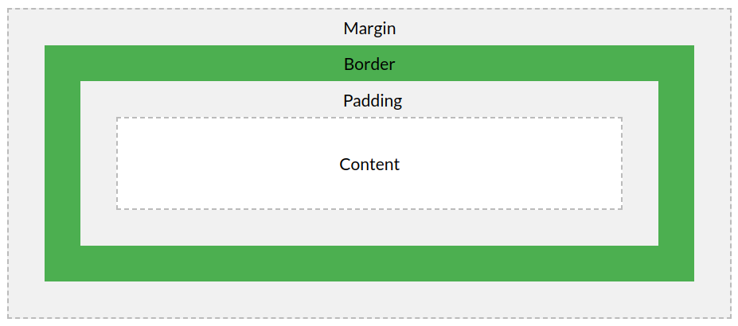
Margin - Clears an area outside the border. The margin is transparent

The box model allows us to add a border around elements, and to define space between elements.

b) Query:

Query is a request for information from a database. There are 3 general methods of posing queries, which are enlisted below:

i) Choosing parameter from menu: In this method, the database systems present from which you can choose. This is perhaps the easiest way to pose a query because the menus guide you, but it is also the least flexible.

i)Query by Example (QBE): In this method, system presents a blank record and lets you specify the fields and values that defines query.

ii) Query Language: Many database system require to make request for information to make request for information in the form of a stylized query that must be written in the special query language. This is most complex methods because it forces you to learn specialize language, but it is also the most powerful.

c) String and Window objects: String store a series of characters like “James Bond”. A string can be any text inside double or single quotes. String indexes double or single quotes. String indexes are zero-based(i.e The first character is in position O, the second is in 1 and so on).

Window objects represents on open window in a browser. If a document contain frames (<iframes>) tags, the browser creates one window object for HTML 6documents, and one additional object for each frame.

5b 2016) Define XML Schema with example. Difference between HTML and XML.
XML schema is a language for expressing constraints about XML document.
HTML | XML
It is used to display data & focuses on how they look. | It is used to transport & store data. It focus on what data is.
It is a markup language. | It provide a framework to define markup language.
It is not case sensitive. | It is case sensitive.
It has its own predefined tags. | We can define tags according to our need.
It is not necessary to use a closing tag. | It is mandatory to use closing tag.
It is static because it is used to display data. | It is dynamic because it is used to transport data.
It doesn’t preserve white spaces. | It preserve white spaces.

____________________________________________________________________________________________________________________________________________________________

4b 2016) What is DOM? Explain object method & DOM nodes.

Object method: When an HTML document is loaded into a web browser, it becomes a document object. The document object is the root node of HTML document. Some document object methods are:
addEventListner(), createComment(), close(), createEvent(), createAttribute(), write(), etc.

DOM nodes: DOM Node is an interface from which a number of DOM API objects inherit. It allows various types to be treated similarly, for example inheriting the same set of methods, or being tested in the same way.

___________________________________________________________________________________________________________________________________________________________

7 b 2016)

Get & Post Method: Get is used to request data from a specified resource. It is one of the common HTTP method.
Post is used to send data to a server to create/update a resource. The data sent to the server with post is stored in the request body of the HTTP request.

